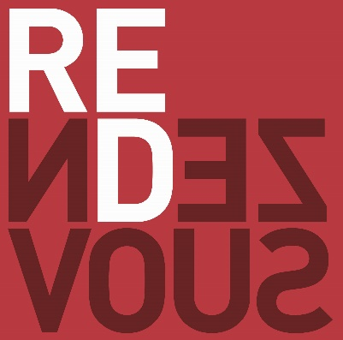

FREEZOUT
BLIND STRUCTURE

LEVEL | SMALL BLIND | BIG BLIND | BIG BLIND ANTE | LEVELS | BREAK
1 | 25 | 50 | - | 30 min
2 | 50 | 100 | - | 30 min
3 | 100 | 200 | - | 30 min | 20 min
4 | 200 | 400 | 400 | 20 min
5 | 300 | 600 | 600 | 20 min
6 | 400 | 800 | 800 | 20 min
7 | 600 | 1 200 | 1 200 | 20 min
8 | 800 | 1 600 | 1 600 | 20 min | 20 min
9 | 1 000 | 2 000 | 2 000 | 20 min
10 | 1 500 | 3 000 | 3 000 | 20 min
11 | 2 000 | 4 000 | 4 000 | 20 min
12 | 3 000 | 6 000 | 6 000 | 20 min
13 | 4 000 | 8 000 | 8 000 | 20 min | 15 min
14 | 6 000 | 12 000 | 12 000 | 20 min
15 | 8 000 | 16 000 | 16 000 | 20 min
16 | 10 000 | 20 000 | 20 000 | 20 min
17 | 15 000 | 30 000 | 30 000 | 20 min
18 | 20 000 | 40 000 | 40 000 | 20 min
19 | 25 000 | 50 000 | 50 000 | 20 min | 10 min
20 | 30 000 | 60 000 | 60 000 | 20 min
21 | 40 000 | 80 000 | 80 000 | 20 min

Big Blind Ante:
The table will not post an ante, the player on the big blind will post an equal big blind. Should the big blind not be able to cover the ante and the big blind, the big blind takes priority over the ante, the player will be all in. On the final table with only four players remaining the button ante will drop to the small blind.

