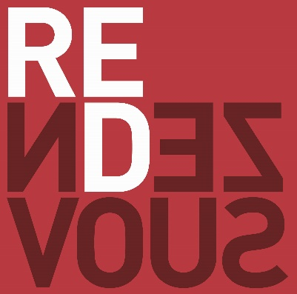

RENDEZVOUS POKER CHALLENGE
DAY 1 BLIND STRUCTURE

LEVEL | SMALL BLIND | BIG BLIND | BIG BLIND ANTE | LEVELS | BREAK
1 | 25 | 50 | - | 30 min
2 | 50 | 100 | - | 30 min
3 | 75 | 150 | - | 30 min
4 | 100 | 200 | - | 30 min | 20 min
5 | 150 | 300 | - | 30 min
6 | 150 | 300 | 300 | 30 min
7 | 200 | 400 | 400 | 30 min
8 | 300 | 600 | 600 | 30 min | 20 min
9 | 400 | 800 | 800 | 30 min
10 | 500 | 1000 | 1000 | 30 min
11 | 600 | 1200 | 1200 | 30 min
12 | 800 | 1600 | 1600 | 30 min | 20 min
13 | 1000 | 2000 | 2000 | 30 min
14 | 1200 | 2400 | 2400 | 30 min
15 | 1600 | 3200 | 3200 | 30 min
16 | 2000 | 4000 | 4000 | 30 min

